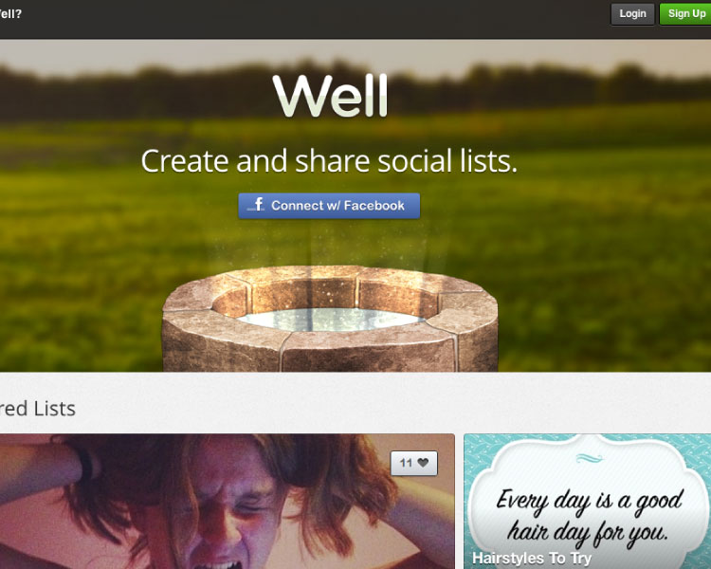Well

<http://well.io/>

Looking at this landing page I noticed they used the company’s logo/name right in the middle of the screen. It really caught my attention, and thought it would be very useful to have on the landing page I was trying to produce.

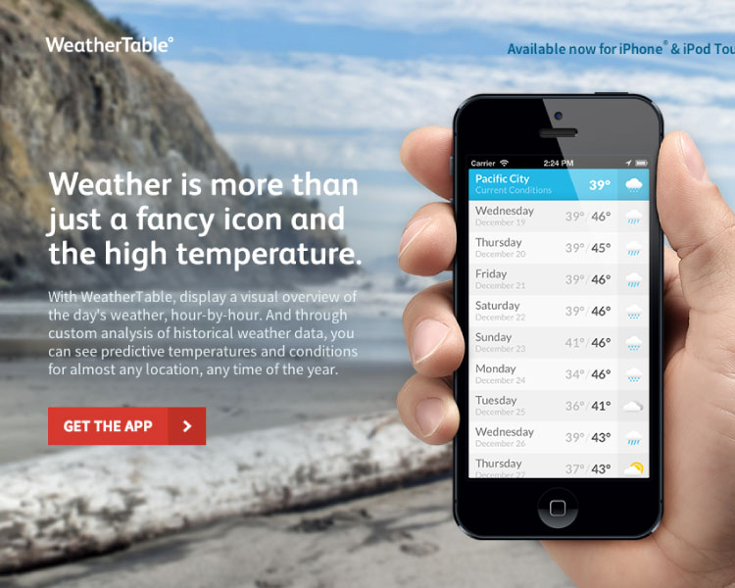WeatherTable

<http://weathertableapp.com/>

WeatherTable displayed their content very well with the summary/description of what their app does. I really liked the blurred out background image, and the display of the app on the iPhone.

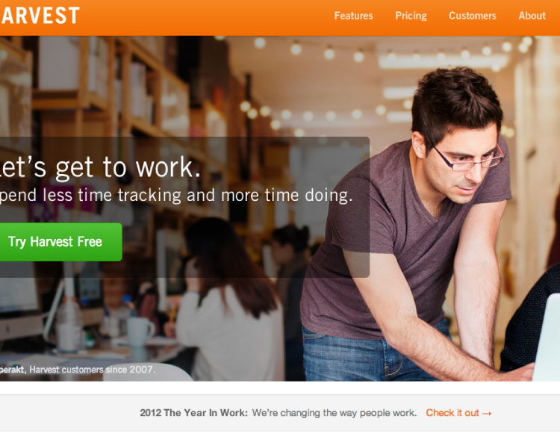Harvest

<http://www.getharvest.com/>

With Harvest I really like how they used the slight transparent background for the content over the background image. As well, I like the size of their call to action button, and how it contrasted with the whole page. Also, the fact that the site also matches the colour scheme in the app was something I took into consideration.

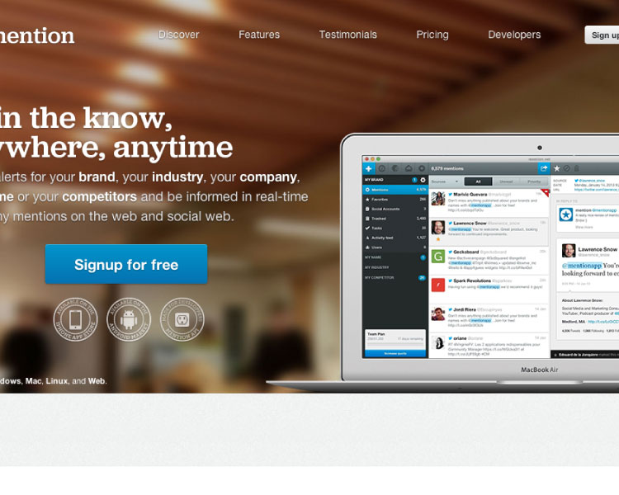

Mention

<https://en.mention.net/>

In Mention they have a great display of what they’re trying to sell, and all the way to use their app. It has a very simple layout that gives the user easy understanding of what they are selling.

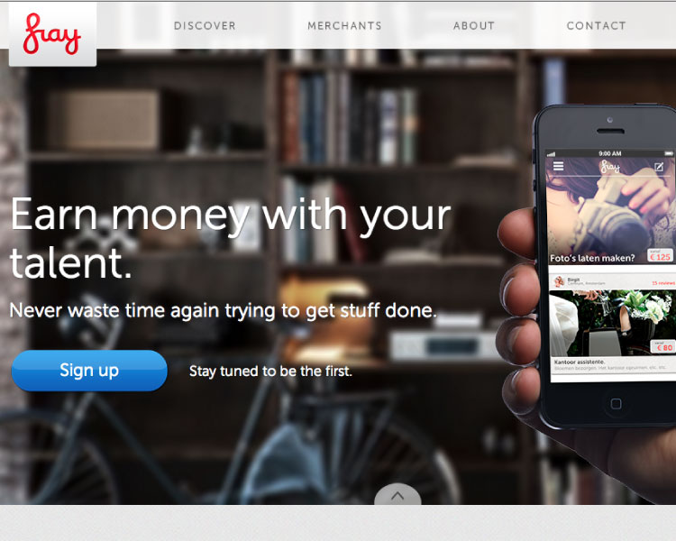

Fray

<http://fray.it/>

I really liked the shape of Fray’s call to action button. Also, the placement of everything on the page using, rule of thirds to make the site more visually appealing. Overall it had a very appealing look that I thought I could use within my landing page.